**Global Perspectives: Exploring the Educational Odyssey of Indian Scholars Abroad - A Power BI Analysis**

**Introduction:**

"Global Perspectives: Exploring the Educational Odyssey of Indian Scholars Abroad" offers a comprehensive analysis delving into the transformative journey of Indian scholars navigating international educational landscapes. This Power BI project provides an insightful exploration into the educational pursuits of Indian students beyond national borders. From the bustling streets of New Delhi to the serene campuses of renowned universities worldwide, this analysis uncovers the diverse experiences and academic endeavors of Indian scholars pursuing higher education abroad.

Embarking on this educational odyssey, Indian scholars venture into unfamiliar territories, driven by aspirations for academic excellence, cross-cultural enrichment, and personal growth. Through meticulous data analysis and visual representations, this project unveils the intricate tapestry of international student mobility, shedding light on the destinations, disciplines, and demographics shaping the educational trajectories of Indian scholars. From bustling metropolises to quaint college towns, each destination offers a unique backdrop for scholarly exploration, fostering intellectual curiosity and global citizenship.

As Indian scholars navigate the complexities of academic pursuits abroad, they encounter a myriad of opportunities and challenges, contributing to their holistic development and global engagement. This Power BI analysis provides valuable insights into the impact of international education on individual lives, academic institutions, and global communities. Through compelling visualizations and data-driven narratives, this project illuminates the educational odyssey of Indian scholars abroad, inspiring a deeper understanding of the transformative power of cross-cultural learning experiences.

**Scenario 1: Identifying Top Destinations**

Analyze data to identify the top destinations preferred by Indian scholars for higher education, uncovering trends in student mobility and academic preferences.

**Scenario 2: Comparative Analysis**

Conduct a comparative analysis of Indian scholars' experiences in different regions, highlighting variations in educational systems, cultural immersion, and career prospects.

**Scenario 3: Impact Of Academic Partnerships**

Explore the impact of academic partnerships between Indian and foreign institutions on student mobility and research collaborations, fostering cross-cultural exchanges and knowledge transfer.

**Technical Architecture:**

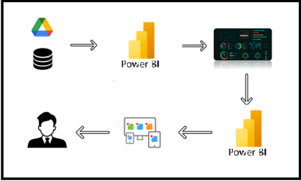

**Project Flow**

To accomplish this, we have to complete all the activities listed below,

* Data Collection
  + Collect the dataset,
  + Connect Data with Power BI
* Data Preparation
  + Prepare the Data for Visualization
* Data Visualizations
  + Visualizations
* Dashboard
  + Responsive and Design of Dashboard
* Report
* Report Creation
* Performance Testing
  + Utilization of Data Filters
  + No. of Calculation fields
  + No. of Visualizations/Graphs
* Project Demonstration & Documentation
  + Record explanation Video for project end to end solution
  + Project Documentation-Step by step project development procedure

**Milestone 1: Data Collection & Extraction from Database**

Data collection is the process of gathering and measuring information on variables of interest, in an established systematic fashion that enables one to answer stated research questions, test hypotheses, evaluate outcomes and generate insights from the data.

**Activity 1: Downloading the dataset**

Please use the link to download the dataset: [Link](https://data.world/harishkgarg/indian-students-abroad-mar-2017)

**Activity 1.1: Understand the data**

Data contains all the meta information regarding the columns described in the CSV files

**Column Description of the Dataset:**

* Country- Name of the Country
* No. Of Indian Students- Representing Indian Students in each Country
* Percentage-Percentage based on Indian Students and Country

**Milestone 2: Data Preparation**

**Activity 1: Prepare the Data for Visualization**

Preparing the data for visualization involves cleaning the data to remove irrelevant or missing data, transforming the data into a format that can be easily visualized, exploring the data to identify patterns and trends, filtering the data to focus on specific subsets of data, preparing the data for visualization software, and ensuring the data is accurate and complete. This process helps to make the data easily understandable and ready for creating visualizations to gain insights into the performance and efficiency. Since the data is already cleaned, we can move to visualization.

3.1: Data Loading

[Link](https://drive.google.com/file/d/178AhmQjn1tY2ol8BfRzWD_Bp4_NDX_Ss/view?usp=drive_link)

3.2 Data Cleaning

[Link](https://drive.google.com/file/d/104lUwAMKuWkd7z4eBal8IHjFK9tFdmdW/view?usp=drive_link)

**Milestone 3: Data Visualization**

Data visualization is the process of creating graphical representations of data to help people understand and explore the information. The goal of data visualization is to make complex data sets more accessible, intuitive, and easier to interpret. By using visual elements such as charts, graphs, and maps, data visualizations can help people quickly identify patterns, trends, and outliers in the data.

**Activity 1: Indian Scholars Abroad**

**Activity 1.1: Total Indian Students**

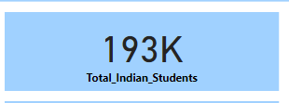

**Activity 1.2: Sum Of Percentage Of Indian Students**

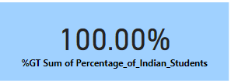

**Activity 1.3: Countries Percentages**

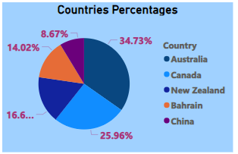

**Activity 1.4: Population Percentage**

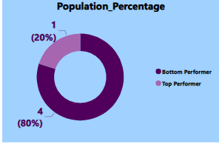

**Activity 1.5: Number of Students in Countries**

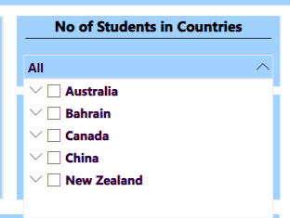

**Activity 1.6: Average Indian Students**

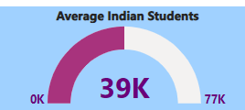

**Activity 1.7: Sum of No. of Indian Students by Country and Region**

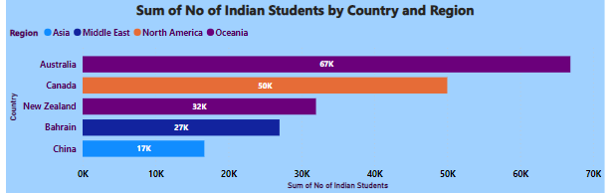

**Activity 1.8: Sum of Percentage and Rank Country by Country**

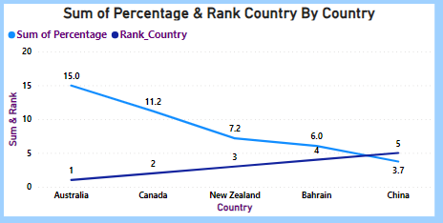

**Activity 1.9: Average and Total Indian Students by Country**

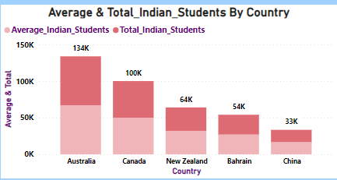

**Activity 1.10 : Sum and Percentage of No. of Indian Students**

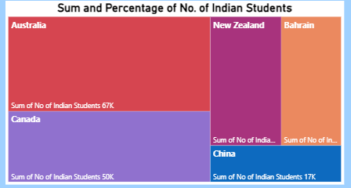

**Activity 1.11 : Total Indian Students by Country and Region**

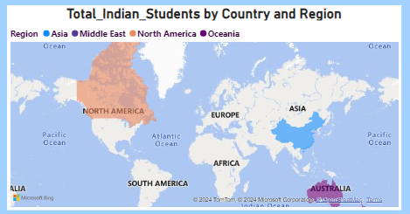

**NOTE:** Video Explanations for the above Visualizations are in Dashboard and Report sections.

**Milestone 4: Dashboard**

A dashboard is a graphical user interface (GUI) that displays information and data in an organized, easy-to-read format. Dashboards are often used to provide real-time monitoring and analysis of data and are typically designed for a specific purpose or use case. Dashboards can be used in a variety of settings, such as business, finance, manufacturing, healthcare, and many other industries. They can be used to track key performance indicators (KPIs), monitor performance metrics, and display data in the form of charts, graphs, and tables.

**Activity 1- Responsive and Design of Dashboard**

**Explanation video link:**

[Link](https://drive.google.com/file/d/1-CFRq3abPyNCSd6zJsj7VH8y-tJrxTTj/view?usp=drive_link)

**Dashboard:**

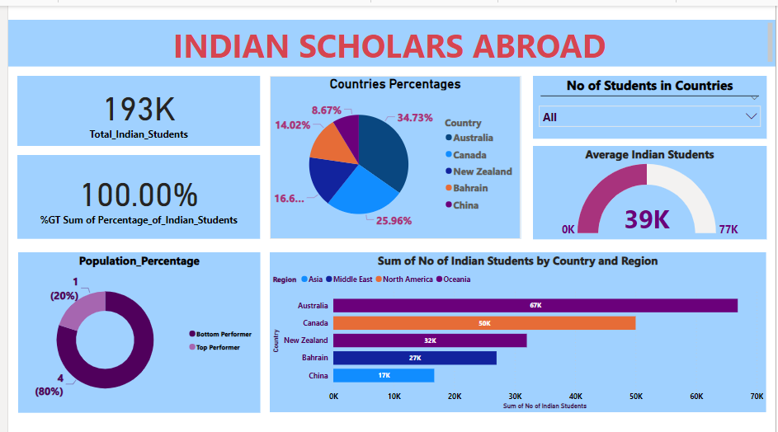

**Milestone 5: Report**

A report is a comprehensive document that provides a detailed and structured account of data analysis, findings, and insights. It is typically used for in-depth analysis, documentation, and communication of results. Reports are suitable for a diverse audience, including decision-makers, analysts, and stakeholders who need a comprehensive understanding of the data.

**Activity 1: Design of Report**

Designing a report in Power BI involves connecting to data sources, creating visualizations like charts and graphs, customizing their appearance and interactivity, organizing them logically on the canvas, formatting elements for consistency and clarity, and optionally creating dashboards for a summarized view. Throughout the process, it's essential to consider the audience's needs and ensure the report effectively communicates insights from the data. Finally, iterate based on feedback to continually improve the report's design and usefulness.

**Explanation video link:**

[Link](https://drive.google.com/file/d/197qx0v3fsy1_n9Xh0tjcEdYqwxX39PFU/view?usp=drive_link)

**Report:**

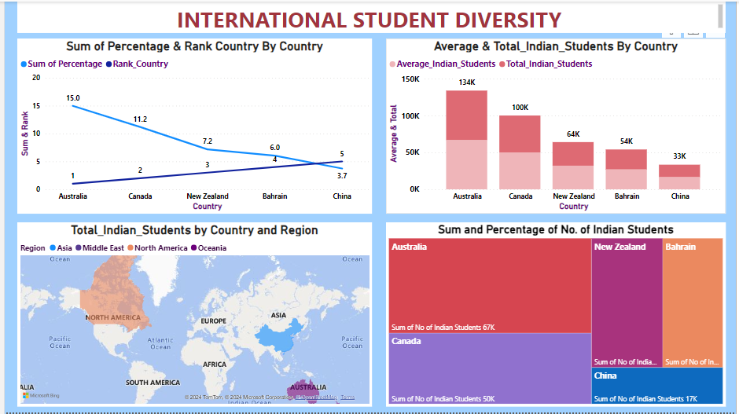

**Milestone 6: Performance Testing**

**Activity 1: Amount of Data Loaded**

"Amount of Data Loaded" refers to the quantity or volume of data that has been imported, retrieved, or loaded into a system, software application, database, or any other data storage or processing environment. It's a measure of how much data has been successfully processed and made available for analysis, manipulation, or use within the system.

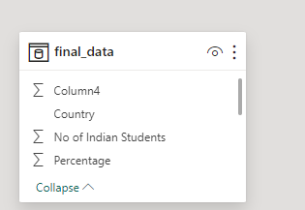

**Activity 2: Utilization of Filters**

"Utilization of Filters" refers to the application or use of filters within a system, software application, or data processing pipeline to selectively extract, manipulate, or analyze data based on specified criteria or conditions.

**Activity 2.1: Selected “Country” as a Filter**

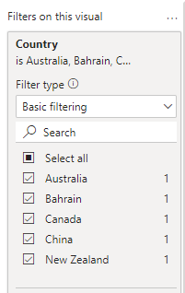

**Activity 3: No of Calculation Fields**

**Activity 3.1: Measure**

In Power BI, a measure is a calculation based on data in your dataset. Measures are created using DAX (Data Analysis Expressions), a formula language that allows you to perform calculations, create aggregations, and define business logic. Measures can perform various functions such as summing values, calculating averages, counting occurrences, or performing complex calculations based on conditions.

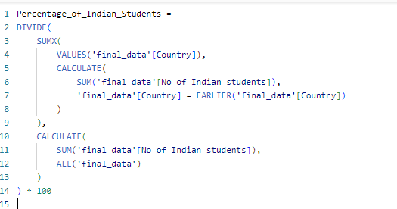



**Activity 4: No of Visualizations/ Graphs**

1. Total Indian Students
2. Sum of Percentage of Indian Students
3. Average of Indian Students
4. Countries Percentages
5. No. of Students in Countries
6. Population Percentage
7. Sum of No. of Indian Students by Country and Region
8. Sum of Percentage and Rank Country by Country
9. Average and Total Indian Students by Country
10. Total Indian Students by Country and Region
11. Sum and Percentage of No. of Indian Students